OZcoin, Inc. develops the OZcoin Platform, and

OZcoin as the “Gold-backed Cryptocurrency”

Contents

Overview 4

Technical Overview – Issue OZcoins 4

Key Products 5

1. The OZcoin Portal 5

2. Asset Backed OZcoins 5

Key Processes 5

1. Proof of Asset Verification 6

1.1 The Auditing Process 7

2. The OZcoin Minting Process 7

3. Customer Registration & Token Information Capturing 8

4. The OZcoin Sales Process 8

5. Redemption Process 9

Key Contracts and Elements 9

1. Customer Registration Contract 9

2. OZcoin Contract 10

3. OZcoin Transaction Contract 10

4. Wallet 10

5. Redemption Contract 11

OZcoin Proof of Asset Participants 11

Asset Vendor 11

Independent Auditor 11

Blockchain is a Multi-party Trust Mechanism 11

Mitigating Potential Points of Failure with Real World Governance 11

Dishonest Entities and collusion in the chain of custody 11

Key Benefits 11

No centralized database management of Crypto-Asset records 11

No Web-based log-in 11

Perpetual Existence of Digital Assets 12

Ex-post facto Incentivization Mechanism 12

The Auditor 12

Wealth Inheritance 12

Escrow 12

Crowdfunding 12

Gold Backed Cryptocurrency Developments 12

Crypto Exchanges and Wealth Management Dapps 12

Collateral services 12

Conclusion 12

Appendix 14

IPFS 14

# Overview

OZcoin, Inc. has a system (the OZcoin Platform) that provides an alternative funding mechanism for ABC Gold company (Company). This is achieved through a Cryptocurrency (OZcoins) that are 100% backed by gold, a combination of one third (1/3) physical gold and two thirds (2/3) contract-for-future-delivery for gold from the company’s proven gold resources.

Although the Cryptocurrency is 100% backed by gold, it would not be redeemable for physical gold for a period of 5 years from 1st March 2017, namely after 1st March 2022. [**NOTE**: No storage fees will be accrued nor will storage fees be charged to OZcoin owners].

The OZcoin Platform utilizes 3rd Gen. blockchain and the InterPlanetary Files System (IPFS) to track an asset through its chain of custody. This allows for the open and public verification of an asset's existence without a centralized database.

# Technical Overview – Issue OZcoins

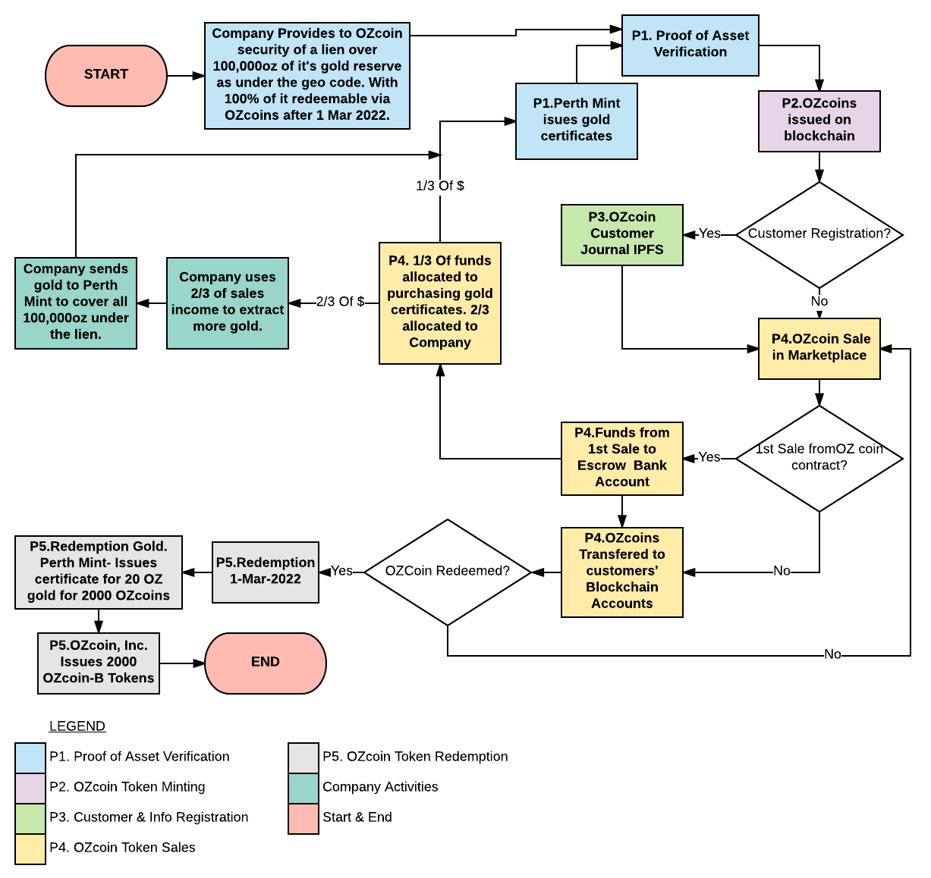

**FlowChart-1: Product Life Cycle**

# Key Products

The OZcoin Platform incorporates several key products.

## 1. The OZcoin Portal

The OZcoin Portal is one of possibly many distribution tools. It is simply a web app through which any other website or web app could be reached via PHP, html or JavaScript and does not form part of this whitepaper.

## 2. Asset Backed OZcoins

OZcoins are minted (issued) via a central OZcoin, Inc. administration account on the blockchain. Every 100 OZcoins represent one ounce of gold of which one third is physically stored in the Central Mint and two thirds are part of the Company’s proven, registered reserves. Proof of Asset for both these are as per the Proof of Asset (PoA) process described below.

The Cryptocurrency is one hundred percent (100%) backed by gold and they are redeemable for physical gold after 1 March 2017, five years from the date that the first OZcoins are issued. The resource backing the currency consists of two components:

1. One third (1/3) of the resource is in the form of pure gold that is stored at the Central Mint with gold certificates issued by the Central Mint as proof of authenticity. The certificates are kept in escrow by an escrow agent.
2. Two thirds (2/3) of the gold forms part of the Company’s proven gold reserves and resources as in accordance with the Australian JORC Reporting code 2012. This portion of the resource will be extracted and processed over a period of five (5) years from the date of the release of the first OZcoins. At which point one hundred percent (100%) of the physical gold will be redeemable via OZcoins. As Proof of Asset the company will issue gold certificates with the future delivery date of 1 March 2022. As extraction progresses at Gold Mine, the 99.9% pure gold will be delivered to and stored in the Central Mint and the Central Mint will issue Mint gold certificates, these certificates will replace the Company’s issued certificates. Quarterly audits will be conducted to confirm (1) Mint certificates are current, and (2) additional Mint certificates (if any) are issued by the Central Mint after delivery of gold by Company – these certificates will replace the Company’s certificates. All gold certificates will be maintained and recorded by the appointed escrow agent.

OZcoins are accessed in 3rd Gen. blockchain accounts via specified 3rd Gen. blockchain wallets.

# Key Processes

There are FIVE modular processes that the OZcoin Platform uses to provide proof of existence and fungibility for the assets in question and to ensure compliance of the OZcoin Platform with possible future international and US cryptocurrency regulations.

1. The Proof of Assets (PoA) Verification process.
   1. The auditing process is a sub-part of the Proof of Asset Verification Process.
2. The OZcoin Minting Process.
3. The Customer Registration and OZcoin Information Capturing Process.
4. The OZcoin Sales Process
5. Redemption:
   1. The process through which OZcoins can be Redeemed for physical gold, and
   2. The process through which replacement OZcoin, known as OZcoin-B, will be issued. **[NOTE**: OZcoin-B will not be asset backed by gold.]

## 1. Proof of Asset Verification

The Proof of Asset (PoA) Verification process records and provides an audit trail of the relevant assets backing the issued OZcoins. The OZcoins’ authenticity and correct asset value backing are certified using sequential digital signatures from the entities in the chain of custody, namely, the Company, Central Mint, Escrow Agent and Independent Auditor, which are further validated with proof of delivery to the Central Mint through the provided Mint issued gold certificates and uploaded onto the blockchain for permanent record.

**FlowChart-2: OZcoin Proof of Asset Verification Process**

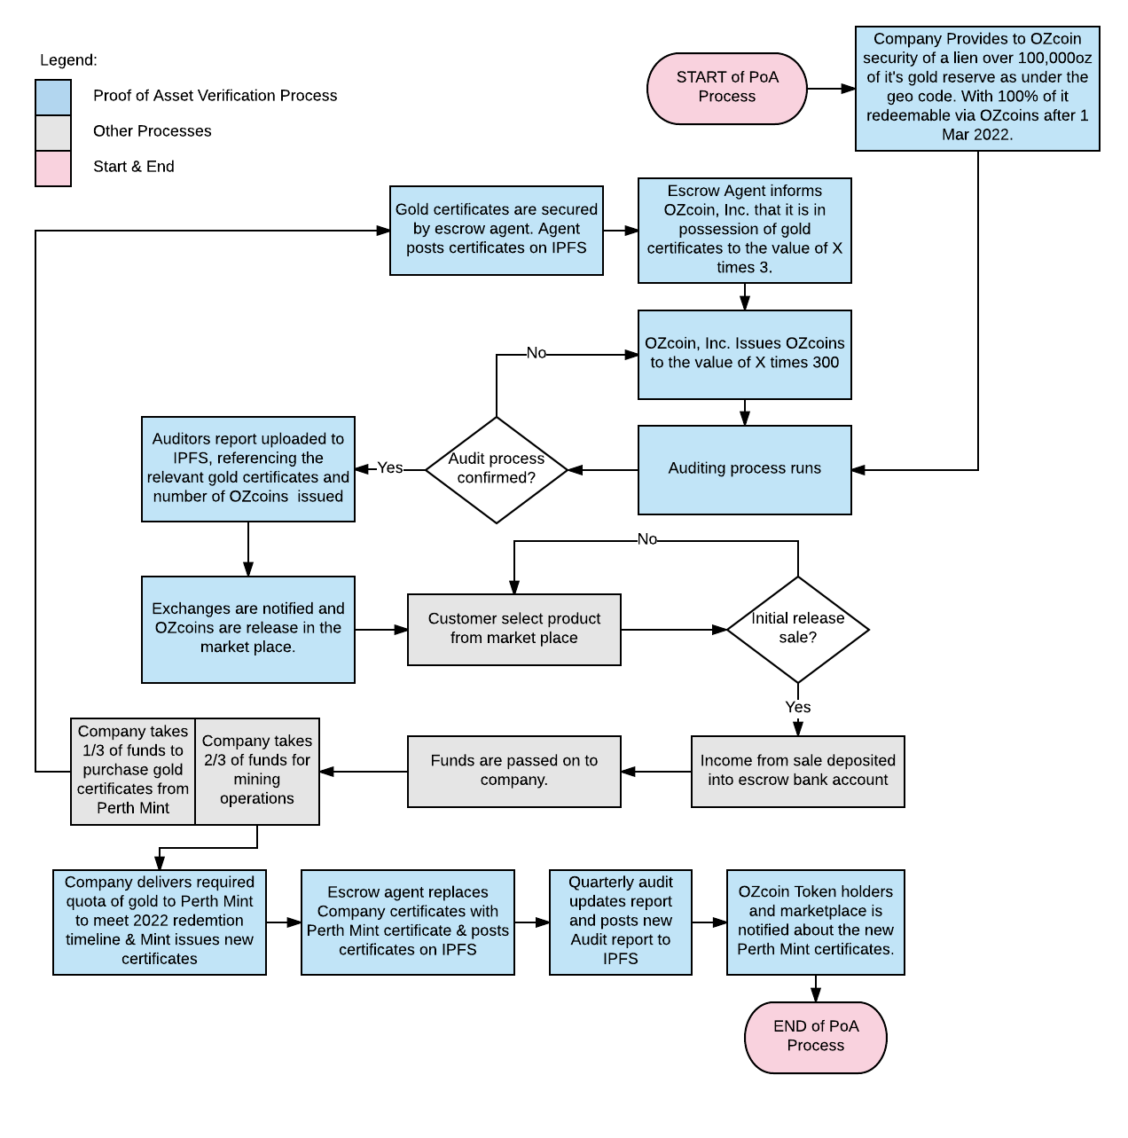

### 1.1 The Auditing Process

The Proof of Asset (PoA) Verification contains a sub-process for regular audits as shown in (Fig 2).

**FlowChart-3: Audit Process**

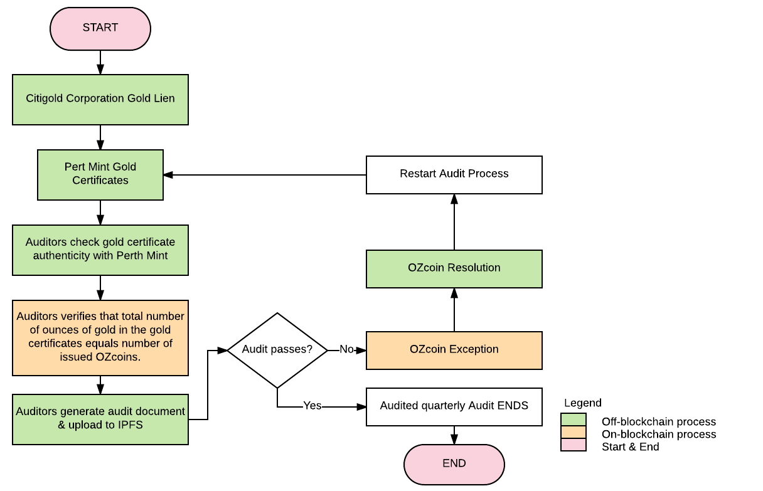

## 2. The OZcoin Minting Process

The OZcoin cryptocurrency denomination breakdown looks as follow:

|  |  |  |  |
| --- | --- | --- | --- |
| Denomination | Value in OZC | Value in Dollar | OZ of Gold |
| ozOZC | 100 | $1,000.00 | 1 oz |
|  |  |  |  |
| OZC | 1 | $10 | 0.01 oz |
|  |  |  |  |
| mOZC | 0.001 | $0.01 | 0.00001 oz |
|  |  |  |  |
| uOZC | 0.000001 | 0.00001 | 0.00000001 oz |

**FlowChart-4: Minting OZcoin Tokens**

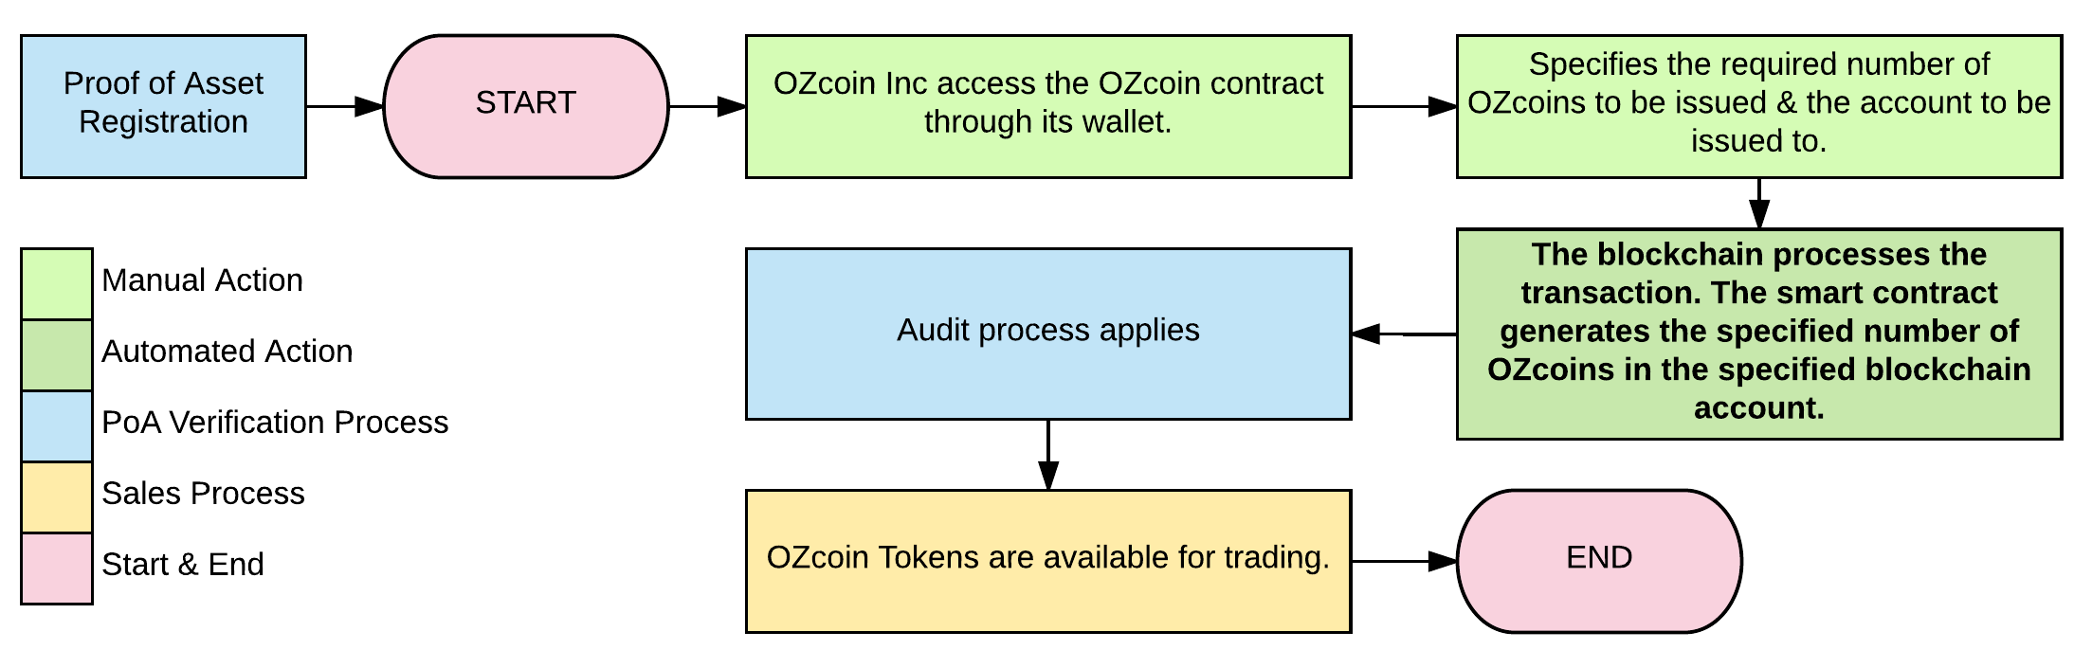

## 3. Customer Registration & Token Information Capturing

This process will include the registration of personal information and is optional for customers in countries and regions where regulations may become a future issue. This information will be kept in a separate 3rd Gen. blockchain contract.

As part of the OZcoin Platform the following information will be permanently uploaded onto the IPFS and blockchain

* Time Stamp of coin creation
* SKU of the “Gold certificate”
* “Gold certificate” serial number [**NOTE**: 70% of the “serial number” will be redacted to prevent duplication; however, the Auditor-Escrow agent will verify each certificate]
* Chain of Custody digital signatures (Vendor, Custodian, Auditor)
* Audit Documentation
* Depository Receipt “Gold certificate”

[**NOTE: The Central Mint does NOT require storage fees from OZcoin owners**]

## 4. The OZcoin Sales Process

**FlowChart-5: The Sales Process**

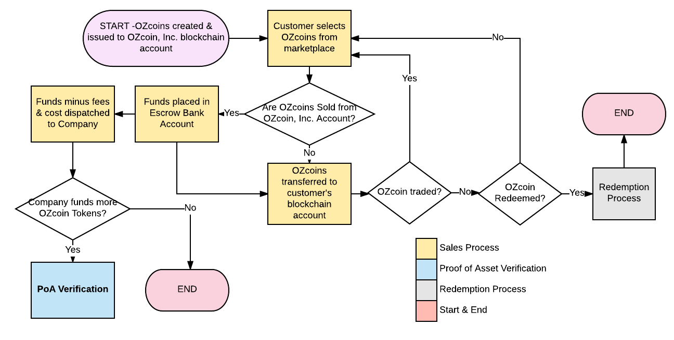

## 5. Redemption Process

Redemption Smart Contract, which is used to exchange OZcoin tokens into a Gold certificates issued by Mint – there certificates are redeemable into 20 oz cast-gold bars (FlowChart-6).

**FlowChart-6: Redeeming 200 OZcoins into 20oz Gold Certificates**

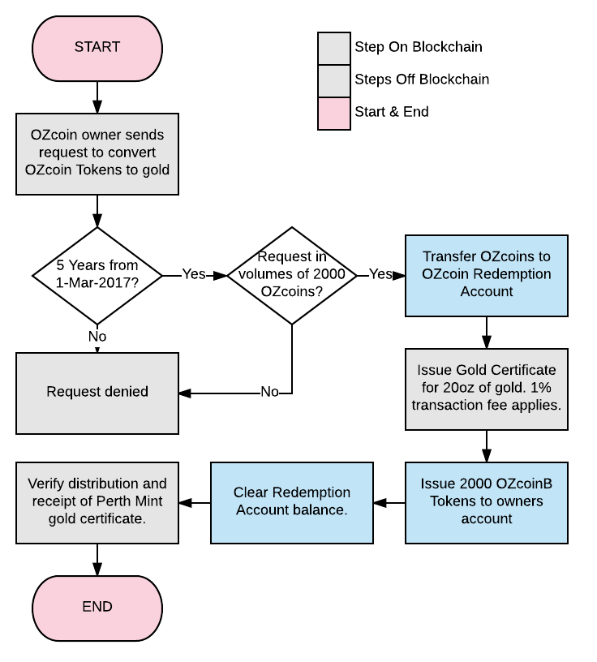

# **Key Contracts and Elements**

The following main contracts are required:

1. Customer registration contract (IPFS)
2. OZcoin Contract
3. OZcoin Transaction contract
4. Wallet
5. OZcoin Redemption contract

## 1. Customer Registration Contract

“Registering” to purchase an OZcoin is optional. This is simply a mechanism through which OZcoin owners can receive newsletters and other information and communication regarding OZcoin. All customer information will be kept on the IPFS.

## 2. OZcoin Contract

The OZcoin Contract must include the following functions:

1. Set the Contract owner as OZcoin, Inc.
2. Set OZcoin, Inc. and ONLY OZcoin, Inc. as a Central Contract Administrator.
3. Set the initial balance as zero
4. Have a conditional Transfer function. Set with a modifier.
5. Enable minting of additional Tokens by the Contract Owner and the Owner only through a Central Mint.
6. Enable minting to the OZcoin account only.
7. Enable the contract owner with authorization of the Auditor account to freeze/unfreeze specified accounts.
8. Enable an arbitration process.
9. Enable automatic selling and buying from accounts by setting a price in Ether/USD.
10. Charge a % transaction fee in uOZC every time a Token is transferred from one account to another. This fee is to be paid into the contract account or an account that can be set by the Central Administrator.

**Flow-Chart 7 – Arbitration Process**

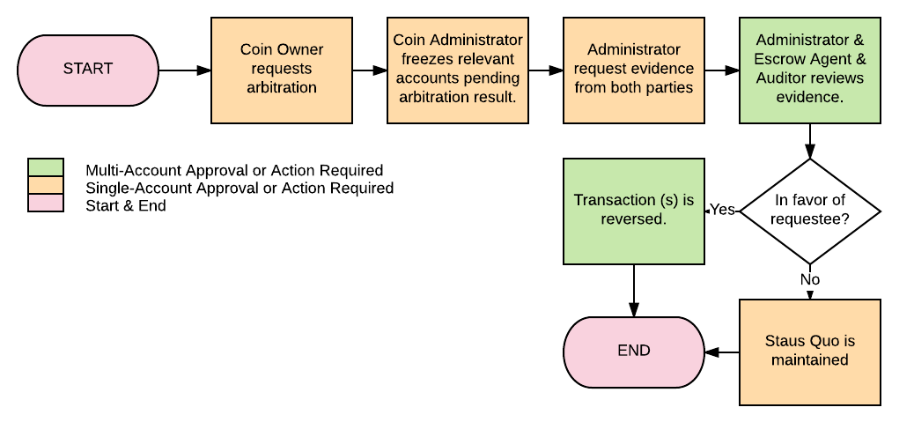

## 3. OZcoin Transaction Contract

This contract needs to capture and display the following information, all an accounts:

1. All the accounts outgoing OZcoin transactions – Send to which account
2. All the accounts incoming OZcoin transactions – Received from which account
3. Time stamp of all transactions
4. OZcoin, Inc.’s transaction fee for each transaction.

## 4. Wallet

The OZcoin should be based on the 3rd Gen. blockchain Token API so that it will work with all 3rd Gen. blockchain compatible wallets. It is therefore perceived that Mist would be one of the acceptable desktop wallets. Numerous Android and IOS wallets exist for 3rd Gen. blockchain and will be investigated.

The wallet or a contract in the wallet should display the current gold price live as to give OZcoin owners an idea of the asset value of their Tokens.

## 5. Redemption Contract

When OZcoins are redeemed, they will be transferred into this account. No OZcoin transfers can take place from this account. When a customer redemption is confirmed and approved in the contract, it removes that number of OZcoins from its balance and create an equal number of OZcoin-B tokens that are assigned to the correct account.

# **OZcoin Proof of Asset Participants**

## Asset Vendor

Central Mint, a publicly listed company, supplies Bullion Markets certified gold bullion bars through the Bullion Marketplace. Established in 1899, they were a branch of Britain’s Royal Mint. The Central Mint is the largest fully integrated Mint in the country of origin, innovative precious metals enterprise, providing premium gold and platinum products and services to markets throughout the world.

## Independent Auditor

Auditors will carry out quarterly checks on the “Gold certificates” provided by Central Mint to ensure accounting is upheld. They are a multinational group with capabilities in an extensive range of commodities, providing independent inspection, sampling and testing services of precious metals.

## Blockchain is a Multi-party Trust Mechanism

The OZcoin blockchain Platform relies on multiple independent participants to provide a transparent platform for the tokenization of physical assets. We can assume that miners in a Proof of Work based cryptocurrency system will act rationally, that is, that they would act in a way to maximize and protect their long term profits by performing their role of transaction verification.

# **Mitigating Potential Points of Failure with Real World Governance**

## Dishonest Entities and collusion in the chain of custody

OZcoin Platform works with entities in jurisdictions that provide stringent regulatory oversight and corporate governance. The entities we have engaged with are either publicly listed or well known in the industry for providing their niche service. Each entity that we have engaged with performs a separate function to prevent cheating. For instance, the asset vendor for physical assets cannot also be the asset custodian. The interest in the service has to be independent of one another.

# **Key Benefits**

## No centralized database management of Crypto-Asset records

All chain of custody information is fully managed by the 3rd Gen. blockchain. This blockchain ledger is immutable with data upload taking significantly less time than on the Bitcoin blockchain.

## No Web-based log-in

There is no web form log-in. Users will download desktop clients from OZcoin. The application itself can also be compiled from source on Github and is publicly auditable. There is significantly less chance of a “Man in the Middle” attack compared to traditional user web-based log-in.

## Perpetual Existence of Digital Assets

All asset data is recorded on the blockchain and exists indefinitely. Every proof generated can be verified and are admissible in a court of law in the applicable jurisdiction.

## Ex-post facto Incentivization Mechanism

The Proof of Asset process requires that regular quarterly or more frequent audits to be performed by a 3rd party auditor on the entire collection of gold assets held at the custodian vaults. The auditor performs a complete audit of “gold certificate” from the Mint, which includes verification of its authenticity and physical examination to detect anomalies or defects.

## The Auditor

Submits a record on the Gold Registry contract for each and every single “gold certificate” that has been audited, which contains an IPFS reference to signed paper documentation, the auditor's 3rd Gen. blockchain identity, and a pass or fail result.

OZcoin Platform receives its revenues through the collection of transaction fees paid in the form of “Ether”.

## Wealth Inheritance

Dead man's switch can be built as a service to allow wealth to be passed on in the form of Crypto-Assets to the mentioned 3rd Gen. blockchain address under the OZcoin Platform.

## Escrow

OZcoin tokens can provide a better and less volatile store of value for Escrow services on the blockchain.

## Crowdfunding

A decentralized app (Dapp) can provide crowdfunding opportunities with cryptocurrencies and crypto-assets, or offer convertibility of cryptocurrencies to OZcoins as a hedge to price volatility.

## Gold Backed Cryptocurrency Developments

Cryptocurrencies can stake a portion of its value with OZcoin Gold tokens and Gold Assets, backing its value with Gold.

## Crypto Exchanges and Wealth Management Dapps

When exchanges integrate OZcoins as a cryptocurrency pair, they will be able to offer a Gold-hedge to cryptocurrencies as part of their service offering. Wealth management services that adjusts your cryptocurrency / crypto asset holdings can be developed to manage an individual's crypto financial risk profile.

## Collateral services

Privately held assets can be safely and efficiently used as collateral without going through lengthy verification process to ascertain an asset's existence and authenticity.

# **Conclusion**

The OZcoin Platform based OZcoin will provide a transparent, audit friendly, safe protocol that leverages the full potential of 3rd Gen. blockchain's decentralized consensus ecosystem and IPFS to facilitate crypto-assets on the blockchain.

# Appendix

## IPFS